Software Requirement Specification

**Document History**

|  |  |  |  |  |  |  |
| --- | --- | --- | --- | --- | --- | --- |
| **Document Name** | **Version** | **Status** | **Date** | **Viewable** | **Reviewer** | **Responsible** |
| iWish-SRS_V.0.1.docx | **Add**   * Introduction * URSA * URSW * SRSA * SRSW * Use Case Diagram * Use Case Description | Draft | 20-05-2015 | VC, SK, KS | VC, SK | VC, SK |
| iWish-SRS_V.1.docx | **Edit**   * Introduction * URSA * URSW * SRSA * SRSW * Use Case Diagram(Web) * Use Case Description (Web) * Use Case Diagram(Android) * Use Case Description (Android) | Release | 22-07-2015 | VC, SK, KS | VC, SK | VC, SK |
| iWish-SRS_V.1.5.docx | **Edit**   * Introduction * URSA * URSW * SRSA * SRSW * Use Case Diagram(Web) * Use Case Description (Web) * Use Case Diagram(Android) * Use Case Description (Android) | Release | 23-08-2015 | VC, SK, KS | VC, SK | VC, SK |

**\*VC = Visava Chumnuam**

**\*SK = Saksorn Khongsirirat**

**\*KS = Kittitouch Suteeca**

**Table of Contents**

1. Introduction 5

1.1 Project Overview 5

1.1.1 Purpose 5

1.1.2 Scope 5

1.1.3 Acronyms …………………………………………………………………………………………....5

1.1.4 User Characteristic…………………………………………………………………………………...5

2. URS 5

3. SRS. 7

4. Use Case Diagram Web 9

4.1 Use Case Description Web 9

5. Use Case Diagram Android 18

5.1 Use Case Description Android 19

# **Introduction**

**1.1 Purpose**

The purpose of software specification is gathering the requirements of the iWish’s software. The document will contain about what are the software should be.

**1.2 Scope**

The application will be develop by Android studio.

* Focus on only one supermarket.
* Provide management system products in database.
* Provide android application for manage wish list.
* Convenient features for android application site.
  1. **Acronyms**

**Acronyms**

ADA Activity Diagram Android

ADW Activity Diagram Web Application

APK Android Package Kit

SDA Sequence Diagram Android

SDW Sequence Diagram Web Application

SK Saksorn Khongsirirat

SRS System Requirement Specification

UCA Use case Diagram Android

UCW Use case Diagram Website

URSA User Requirement Specification Android

URSW User Requirement Specification Website

VC Visava Chumnuam

* 1. **User Characteristic**
     1. **Admin =** the staff of a supermarket which can manage the products in the database and provide information of each product and NFC tag on the shelves.
     2. **Customer** = the people that are a customer of the supermarket and use iWish application.

1. **User Requirements**

- **URSW-01**: Admin can log in to the web application.

- **URSW-02**: Admin can add a new product to the system.

- **URSW-03**: Admin can view all products in the system.

- **URSW-04**: Admin can search product by product’s ID in the system.

- **URSW-05**: Admin can edit product’s information.

- **URSW-06**: Admin can delete the product from the system.

- **URSW-07**: Admin can log out from the web application.

- **URSA-08**: The customer can view the shopping cart that show detail of the product that add by the customer in list format.

- **URSA-09**: The customer can add the new product to the shopping cart by input ID of the product manually or using scanning barcode an amount of the product.

- **URSA-10**: The customer can edit the amount of the product in the shopping cart.

- **URSA-11**: The customer can delete the product from the shopping cart.

1. **Software Requirements Specification**
   * **SRSW-01:** System shall provide login interface to receive ID and password.
   * **SRSW-02:** System shall validate input in a login form.
   * **SRSW-03:** System shall provide all products interface to allow admin to see all products in the system and manage them.
   * **SRSW-04:** System shall show a message “ID and password are incorrect”, if ID, password or both is wrong.
   * **SRSW-05:** System shall provide menu bar to allow admin to change interface between “add product” and “all products”.
   * **SRSW-06:** System shall provide add product interface to receive ID, name, description, categorize, net weigh and price.
   * **SRSW-07:** System shall verify product’s ID with existing product in the database.
   * **SRSW-08:** System shall record product’s information in the database.
   * **SRSW-09:** System shall show a message “Add Success”.
   * **SRSW-10:** System shall provide a search interface to receive product’s ID.
   * **SRSW-11:** System shall retrieve and show products with similar or same as input in a search form.
   * **SRSW-12:** System shall provide edit button in each product for edit product’s information.
   * **SRSW-13:** System shall provide edit product interface with product’s information in a form to receive new product information or add amount require for promotion and promotion price except ID.
   * **SRSW-14:** System shall update product’s information in the database.
   * **SRSW-15:** System shall show a message “Edit Success”.
   * **SRSW-16:** System shall provide delete button on each product for delete product’s information.
   * **SRSW-17:** System shall ask admin for confirming to delete the product.
   * **SRSW-18:** System shall delete the product from the database.
   * **SRSW-19:** System shall show a message “Delete Success”.
   * **SRSW-20:** System shall provide log out button for logout from the web application.
   * **SRSA-21**: The system shall display shopping cart that contain a name, category, net weight, price and amount of product that add by the customer.
   * **SRSA-22**: The system shall provide Add, Edit. Delete button for adding, editing, deleting the product in the shopping cart page.
   * **SRSA-23**: The system shall let the customer add some product by input id of the product manually.
   * **SRSA-24**: The system shall let the customer add some product by scan barcode of the product.
   * **SRSA-25**: After the customer adds some product, the system shall provide information of those products such as name, category, net weight and price to the customer.
   * **SRSA-26**: The system shall let the customer edit amount of each product anytime by click on the amount text box.
   * **SRSA-27**: The system shall let the customer delete the product in shopping cart page by click on "Delete" that are after each of product.
2. **Use Case Diagram (Web Application)**

## 

**Figure 7: Use Case Diagram Web Application**

**Use Case Description (Web Application)**

|  |  |
| --- | --- |
| Use Case ID: | UCW-01 |
| Use Case Name : | Login. |
| Short Description : | Admin can log in to the web application to use other feature of a web application. |
| Actor: | Admin. |
| Pre-Conditions: | The supermarket must provide ID and password. |
| Post-Conditions: | Admin can manage products in the system. |
| Flow Of Events: | 1. The admin enters the web application. 2. The system shall direct “Login” page. 3. The admin input ID and password into a text box, then select “Login”. 4. The system shall validate ID and password. 5. The system shall redirect to “all product” page. |
| Alternative Flow: | From 4., If ID and password are invalid,  5a. The system shall show a message “ID and password is incorrect” |
| Exception: | - |
| Priority: | High |

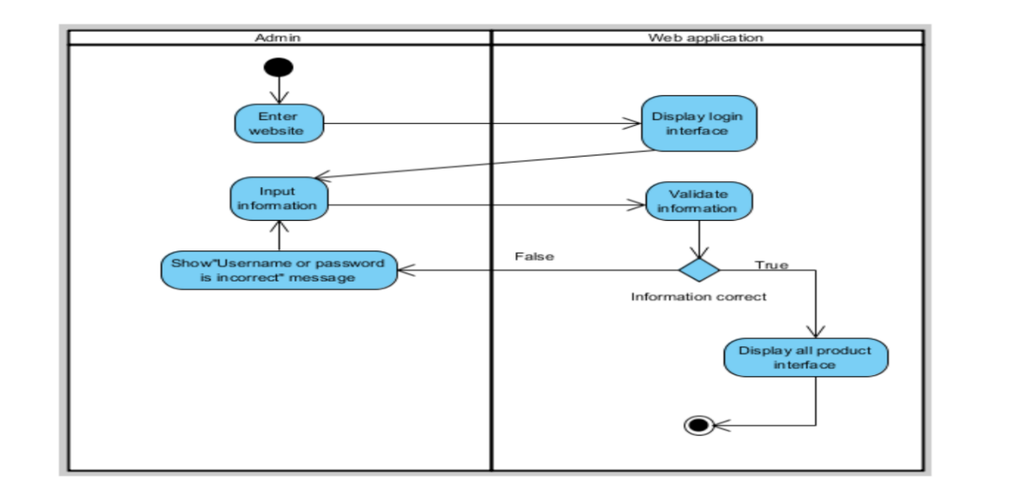

**Figure 8: ADW-01 Login**

|  |  |
| --- | --- |
| Use Case ID: | UCW-02 |
| Use Case Name : | Add new product. |
| Short Description : | Admin can add new a product that doesn’t exist in the system into the system. |
| Actor: | Admin. |
| Pre-Conditions: | Login. |
| Post-Conditions: | - |
| Flow Of Events: | 1. The admin select “Add Product” on menu bar. 2. The system shall redirect to “add product” page. 3. The admin input all information of the product into each text box except promotion part, then select “Add”. 4. The system shall verify product by ID. 5. The system shall create the product in database. 6. The system shall redirect to “all product” page. 7. The system shall show a message “Add Success”. |
| Alternative Flow: | From 4., If the product already exists in the system,  5a. The system shall redirect to “all product” page. |
| Exception: | - |
| Priority: | High |

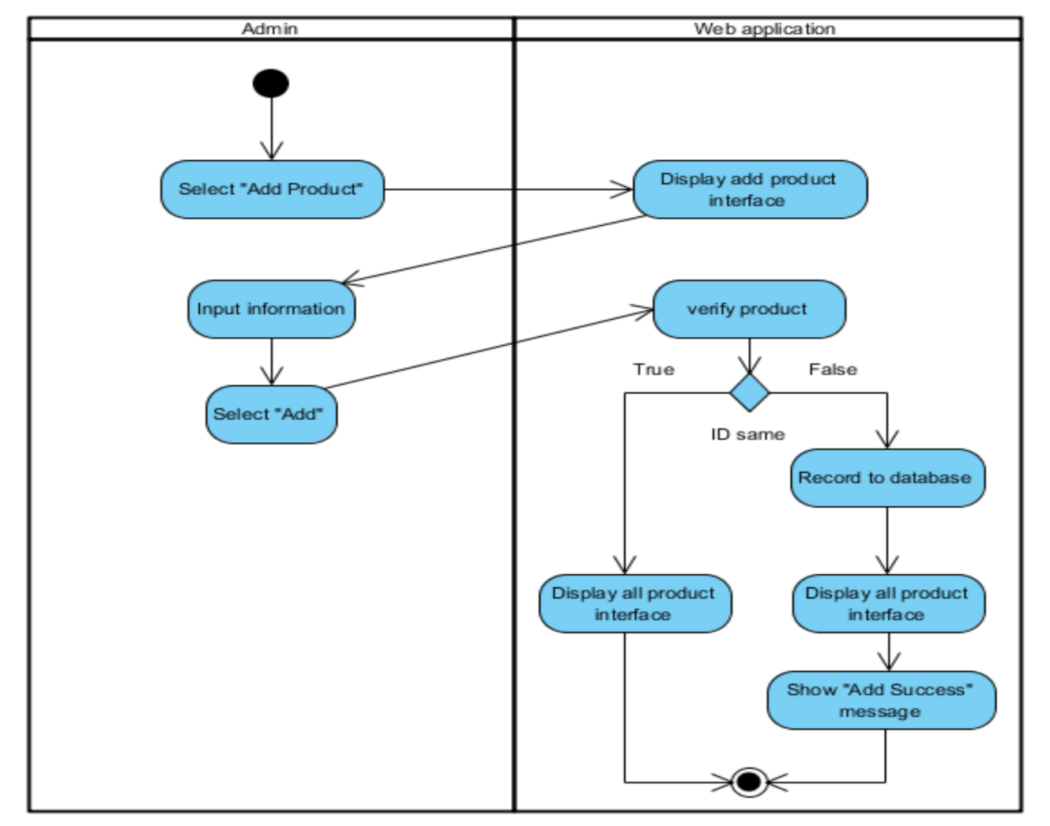

**Figure 9: ADW-02 Add New Product**

|  |  |
| --- | --- |
| Use Case ID: | UCW-03 |
| Use Case Name : | View products. |
| Short Description : | Admin can see all products with detailed that already exist in the system. |
| Actor: | Admin. |
| Pre-Conditions: | Login. |
| Post-Conditions: | - |
| Flow Of Events: | 1. The Admin select "All Product" from menu bar. 2. The system shall redirect to “all products” page. |
| Alternative Flow: | - |
| Exception: | - |
| Priority: | Medium |

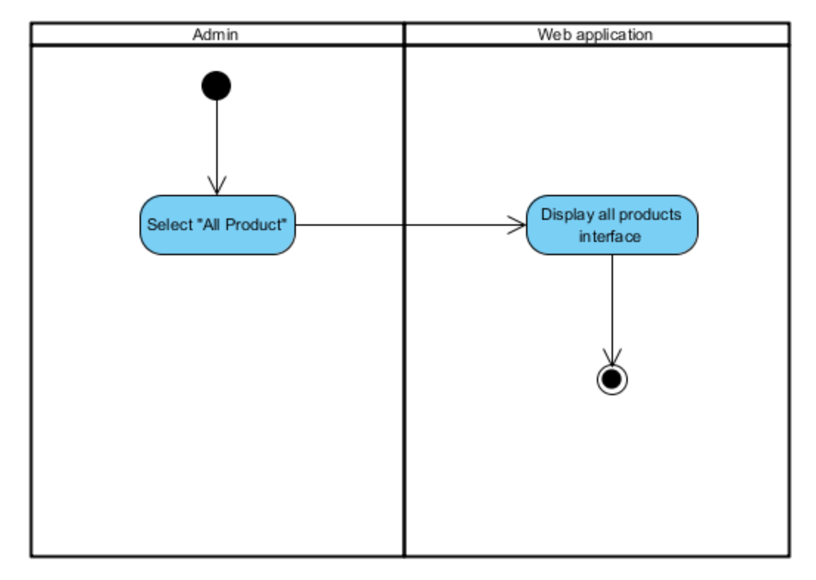

**Figure 10: ADW-03 View Product**

|  |  |
| --- | --- |
| Use Case ID: | UCW-04 |
| Use Case Name : | Search product by ID. |
| Short Description : | Admin can search for products that already exist in the system by product’s id to edit, delete or see the information. |
| Actor: | Admin. |
| Pre-Conditions: | View products. |
| Post-Conditions: | - |
| Flow Of Events: | 1. The admin input product’s id into a search box and selects “search”. 2. The system shall show products with same or similar to product’s id that admin inputted. |
| Alternative Flow: | - |
| Exception: | - |
| Priority: | Medium |

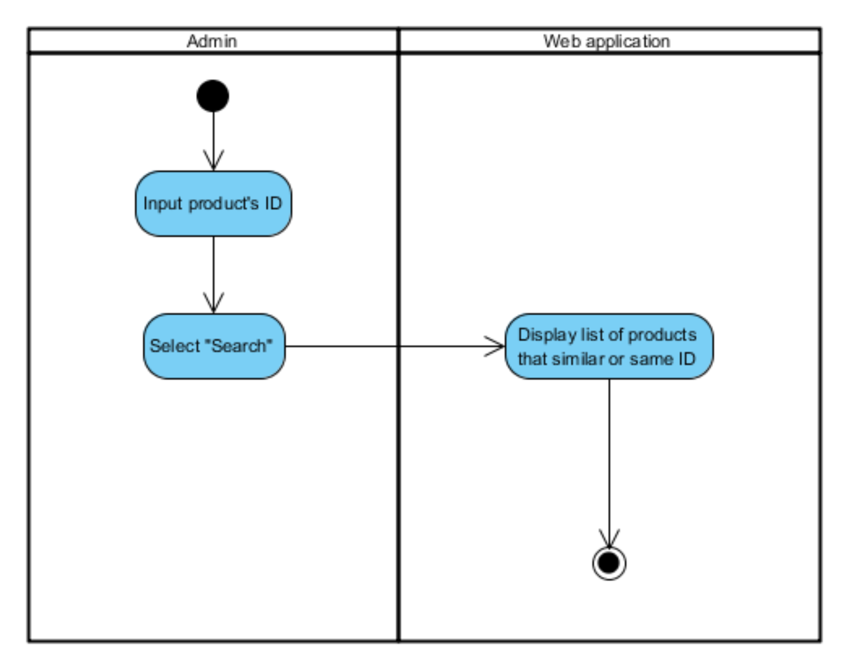

**Figure 11: ADW-04 Search Product by ID**

|  |  |
| --- | --- |
| Use Case ID: | UCW-05 |
| Use Case Name : | Edit product’s information. |
| Short Description : | Admin can edit the information of the product that already exists in the system. |
| Actor: | Admin. |
| Pre-Conditions: | View products. |
| Post-Conditions: | - |
| Flow Of Events: | 1. The admin select “Edit” in row of product that admin want to edit. 2. The system shall retrieve the information of the product and redirect to “Edit” page. 3. The admin edit information that in a text box of each information and then select “Edit”. 4. The system shall update the information of the product in the database. 5. The system shall redirect to “all product” page. 6. The system shall show a message “Edit Success.” |
| Alternative Flow: | - |
| Exception: | - |
| Priority: | High |

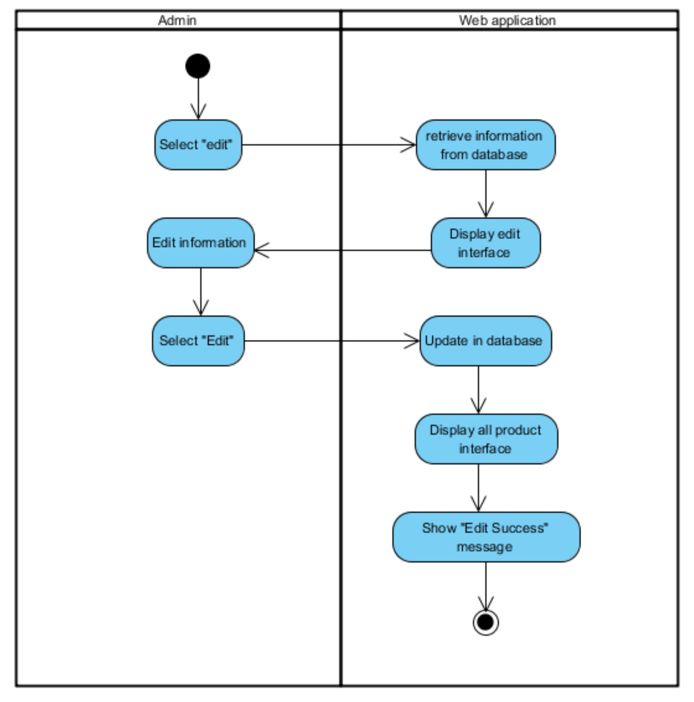

**Figure 12: ADW-05 Edit Product’s Information**

|  |  |
| --- | --- |
| Use Case ID: | UCW-06 |
| Use Case Name : | Delete product. |
| Short Description : | Admin can delete the product that already exists in the system and doesn’t sell anymore to prevent too much record in the database. |
| Actor: | Admin. |
| Pre-Conditions: | View products. |
| Post-Conditions: | - |
| Flow Of Events: | 1. The admin select “delete” in a row of product that admin want to delete. 2. The system shall ask for confirming. 3. The admin select “OK”. 4. The system shall delete the product from the database. 5. The system shall show a message “Delete Success”. |
| Alternative Flow: | From 2., If the admin select “cancel”,  3a. Nothing happen. |
| Exception: | - |
| Priority: | Medium |

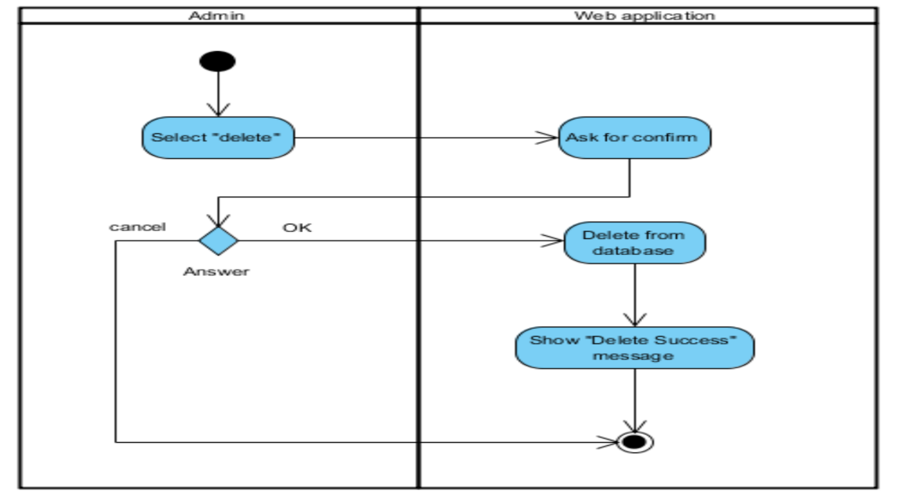

**Figure 13: ADW-06 Delete Product**

|  |  |
| --- | --- |
| Use Case ID: | UCW-07 |
| Use Case Name : | Log out. |
| Short Description : | Admin can log out from the web application for security. |
| Actor: | Admin. |
| Pre-Conditions: | Login. |
| Post-Conditions: | - |
| Flow Of Events: | 1. The admin select "log out". 2. The system redirect to “login” page. |
| Alternative Flow: | - |
| Exception: | - |
| Priority: | Low |

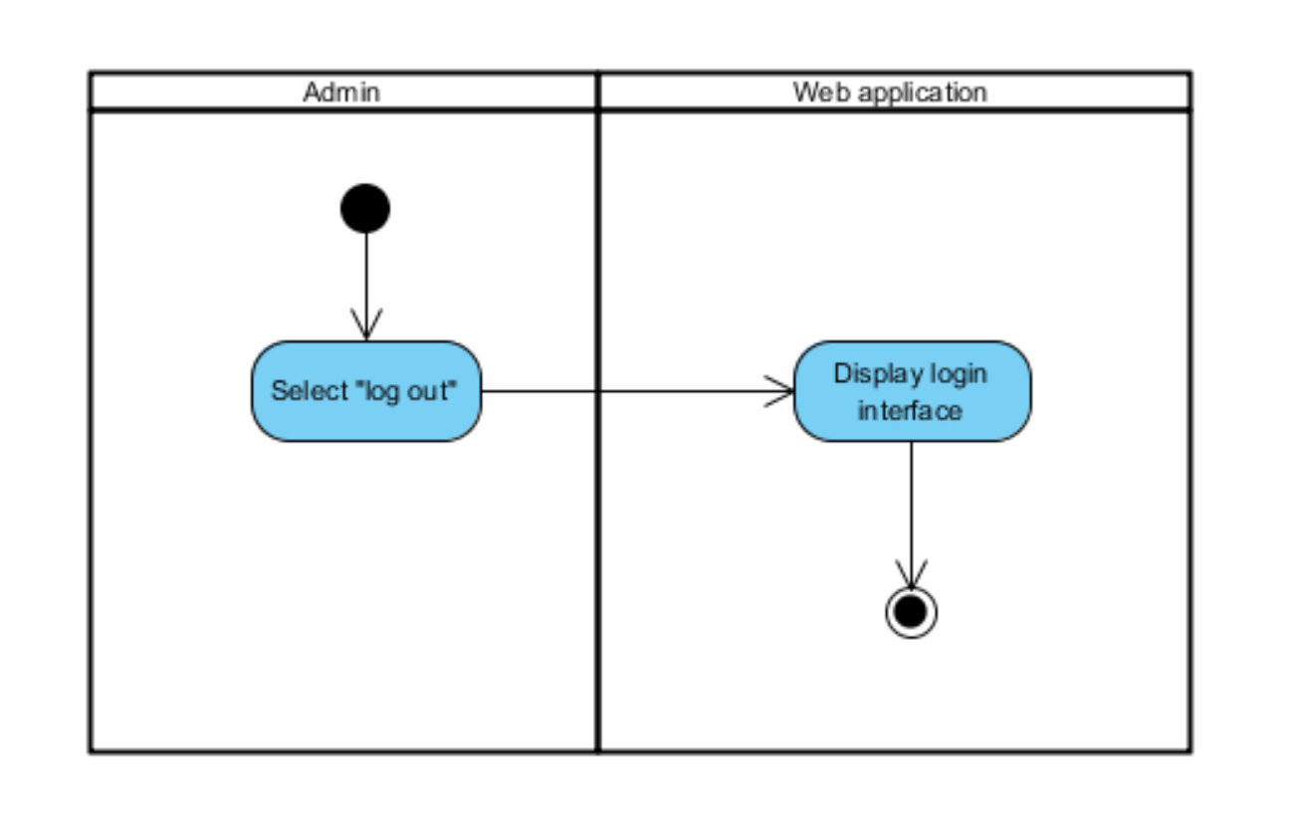

**Figure 14: ADW-07 Log out**

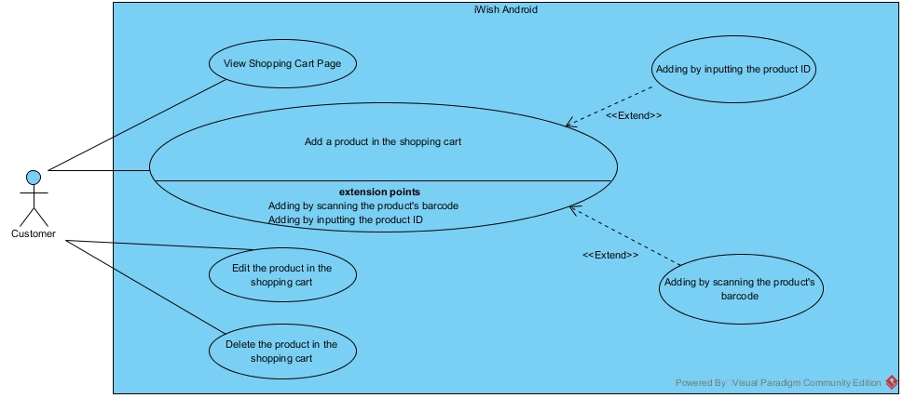

**Figure 15: Use Case Diagram Android Application**

|  |  |
| --- | --- |
| Use Case ID: | UCA-01 |
| Use Case Name : | View shopping cart |
| Short Description : | Customer can view the list of product in the shopping cart. |
| Actor: | Customer. |
| Pre-Conditions: | Launch the application |
| Post-Conditions: | Add / Edit / Delete the product |
| Flow Of Events: | 1. The customer select "Shopping Cart" from menu bar. 2. The system display shopping cart to the customer. |
| Alternative Flow: | - |
| Exception: | - |
| Priority: | Medium |

## C:\Users\nexuspump\Downloads\View shopping cart.jpg

**Figure 16: ADA-01 View**

|  |  |
| --- | --- |
| Use Case ID: | UCA-02 |
| Use Case Name : | Add product to shopping cart. |
| Short Description : | Customer can add a product to the shopping cart of application for doing next process. |
| Actor: | Customer. |
| Pre-Conditions: | The supermarket must provide the product detail in the database. |
| Post-Conditions: | The product show on the shopping cart list. |
| Flow Of Events: | 1. The customer select "Shopping Cart" from the menu bar. 2. The customer select "Add" button. 3. The customer select "Input ID". 4. The customer input the product id of the product that they want to add. 5. The system connects to the database and receive the product details. 6. The system is asking an amount of the product that customer want. 7. The customer input amount of product. 8. The name and the details of the product that user add show on the screen. |
| Alternative Flow: | From 3rd flow, customer can select "Barcode" for adding product into cart by scanning barcode  2. The customer select "Barcode".  3. The system open camera feature.  4. The customer takes a picture on product barcode.  5. The system connects to the database and receive the product details.  6. The name and the details of the product that user add display on the screen.  7. The customer input amount of product.  8. The name and the details of the product that user add show on the screen. |
| Exception: | - |
| Priority: | Medium |

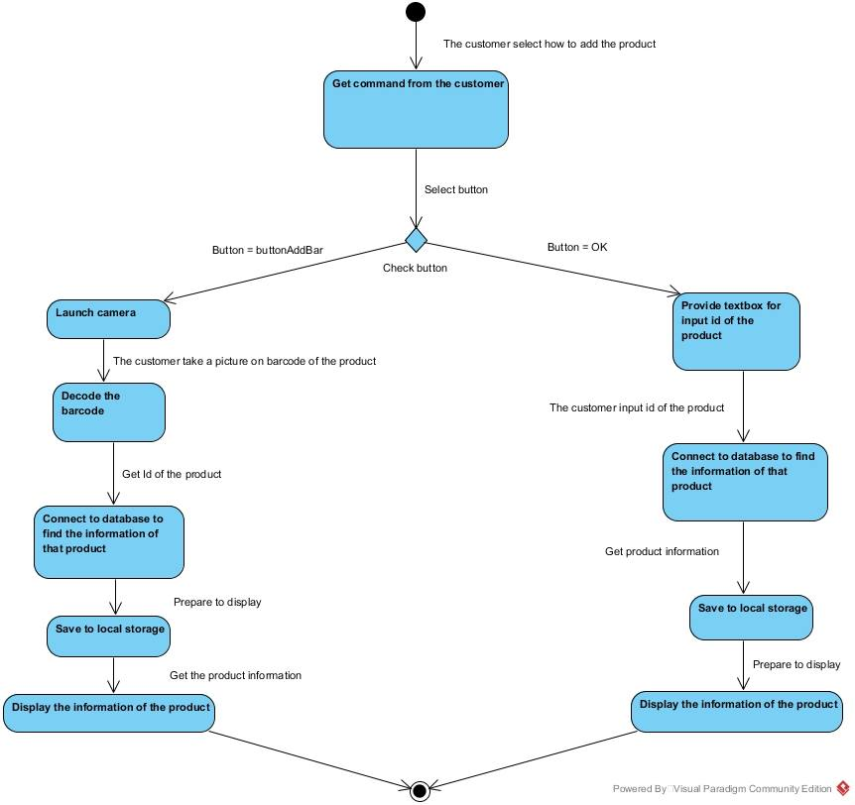

**Figure 17: ADA-02 Add Product in Shopping Cart**

|  |  |
| --- | --- |
| Use Case ID: | UCA-03 |
| Use Case Name : | Edit amount of product in shopping cart. |
| Short Description : | Customer can edit the amount of product in the shopping cart. |
| Actor: | Customer. |
| Pre-Conditions: | The customer have to add some product before. |
| Post-Conditions: | The system receive new data for doing next process. |
| Flow Of Events: | 1. The customer select "Shopping Cart" from menu bar. 2. The customer select "Edit" button. 3. The customer input amount of product. 4. The system save the new amount for next process. 5. The new amount of product that user edit display on the screen. |
| Alternative Flow: | - |
| Exception: | - |
| Priority: | Medium |

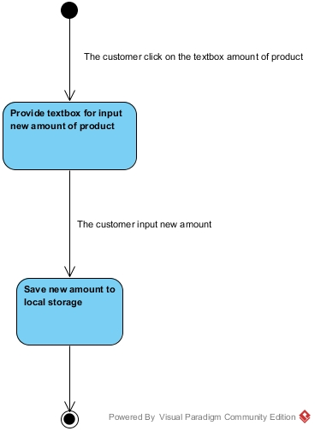

**Figure 18: AD-03 Edit Amount of Product in Shopping Cart**

|  |  |
| --- | --- |
| Use Case ID: | UCA-04 |
| Use Case Name : | Delete the product from the shopping cart. |
| Short Description : | Customer can delete the product from the shopping cart. |
| Actor: | Customer. |
| Pre-Conditions: | The customer has to add some product before. |
| Post-Conditions: | The system save data for doing next process. |
| Flow Of Events: | 1. The customer select "Shopping Cart" from menu bar. 2. The customer select "Delete" button. 3. The system is asking confirmation to the customer. 4. The customer select "Yes" button. 5. The system deletes the product from the shopping cart. |
| Alternative Flow: | From 4th flow, If the customer selects "No" button.  4. The customer select "No" button.  5. The system displays the shopping cart on the mobile screen. |
| Exception: | - |
| Priority: | Medium |

## C:\Users\nexuspump\Downloads\Delete.jpg

**Figure 19: ADA-04 Delete Product from Shopping Cart**